**Documented Report Of Capstone Project SQL+Power BI**

Problem Statement:

**A small company Axon, which is a retailer selling classic cars, is facing issues in managing and analysing their sales data. The sales team is struggling to make sense of the data and they do not have a centralized system to manage and analyse the data. The management is unable to get accurate and up-to-date sales reports, which is affecting the decision-making process.**

**Analysing the sales data and creating easy-to-understand dashboard is the main objective of this report**



**Data Collection**

The primary data source for this analysis is a SQL database ‘Classicmodels’ sql file, containing 8 different tables having information related to customer, employee, offices, orderdetails, orders, payments, productlines and products.

The extracted data was seamlessly imported into Power BI for further analysis and visualization.

**Main Challenges**

**1- Data Quality-** Inaccurate or Incomplete data can lead to unreliable insights. Duplicates, missing values or errors in data entry can affect the analysis.

**2- Seasonal Variations**- Sales often exhibit seasonality and understanding these patterns is essential for accurate analysis and forecasting.

**3- Customer Behavior Understanding-** Gaining insights into customer behavior, preferences, and buying patterns requires sophisticated analysis techniques.

**Objectives**

**1-Identify Underperforming Models-** This insight can guide decisions on marketing strategies, inventory management or potential discontinuation of certain models.

**2- Customer Segmentation-** Break down sales data to understand the demographics and preferences of different customer segments.

**3- Geographical analysis-** This can help identify areas with low sales and potential growth opportunities.

**4- Profitability analysis-** Evaluate the profitability of each product line.

**5- Forecasting and Trend Analysis-** Use historical sales data to forecast future trends. Anticipate shifts in consumer preferences and market demands.

**6- Employee Performance-** Assess individual sales representatives’ performance to identify high performers and those who may need additional support or training.

**Basic Analysis**

**Analyzing key performance indicators**

Analyzing key performance indicators (KPIs) is crucial for assessing the success and effectiveness of various aspects within a car company.

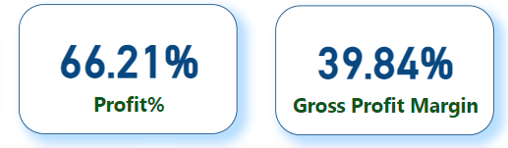

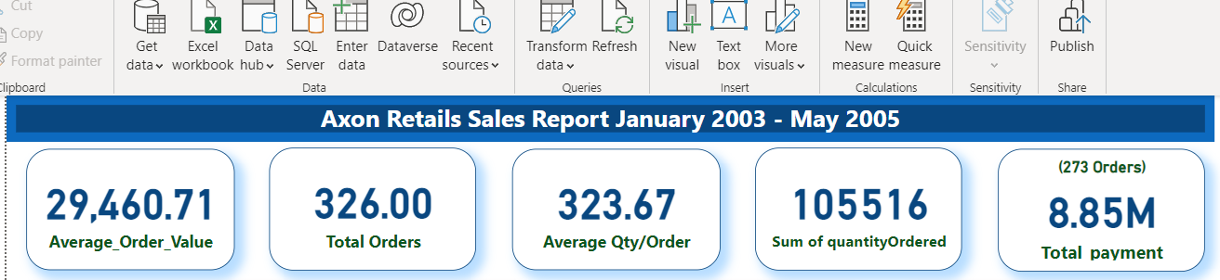

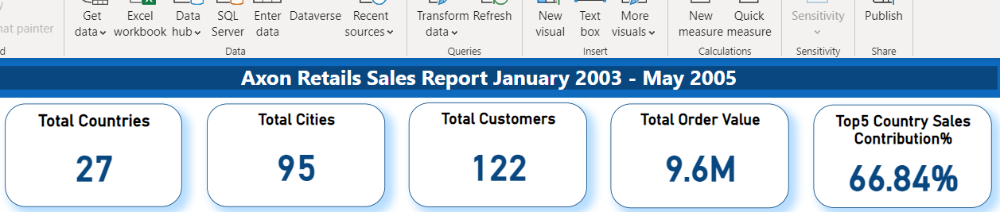

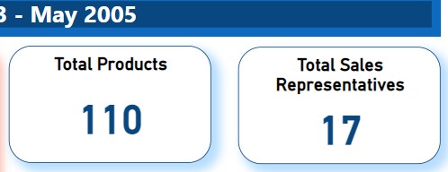

**Profit% , Gross Profit Margin, Total Orders, Sum of Quantity Ordered and Total Payment, Average Qty/Order, Average_Order_Value, Total Countries, Total Cities, Total Customers, Total Selling Price Column**

**Analysing Product Distribution, Product Popularity and Sales Trend**

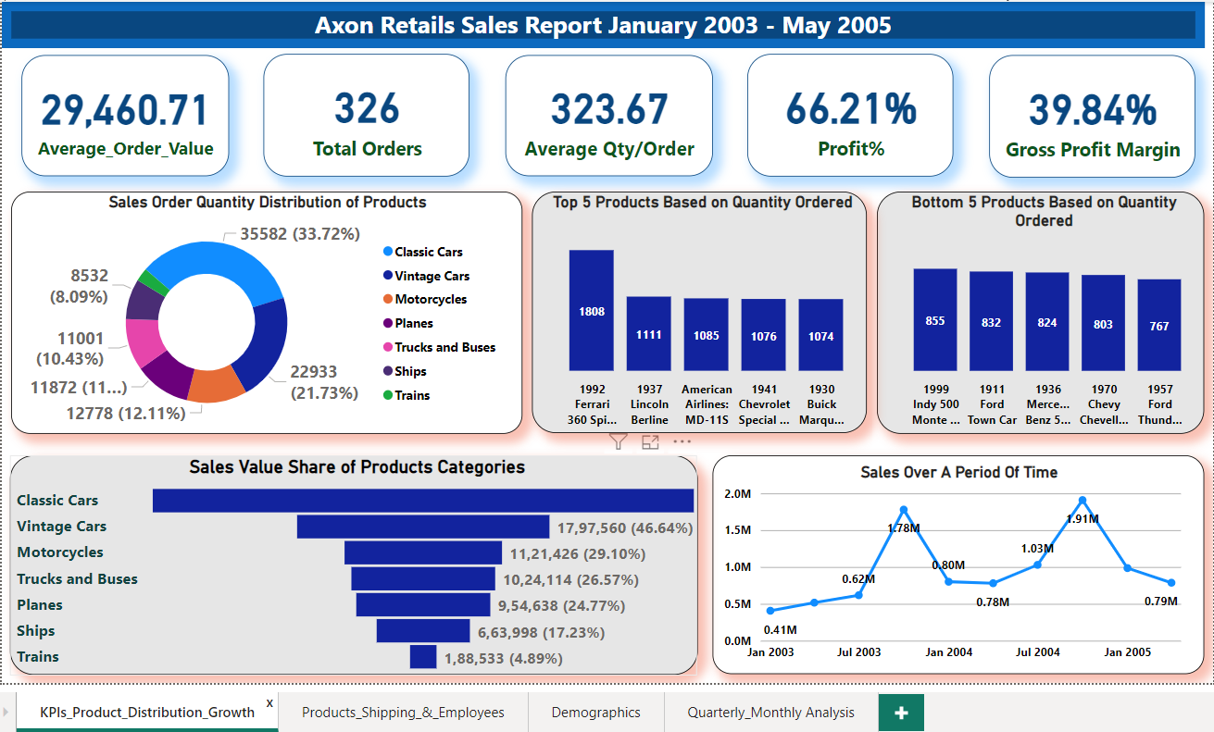

**The Donut Chart- Shows total quantity of products ordered from all the product categories as a percent distribution along with count of quantity**

**The Column Charts- Both the column charts show Top 5 most ordered products and Top 5 least ordered products to get the idea of popularity of the products**

**The Funnel chart- Shows the share of all the product categories in total sales value. It shows the most valuable category of products for the company as well as comparison of other categories with it by showing their percentage with respect to the first (most valuable) category**

**Line chart- It shows the trend of sale over a period of time and that is January 2003 to May 2005, the chart indicates the Sales Boom period and Sales Slump period, over all it follows an upward trend**

**Analysing Products’ Sales Status and Employee Performance**

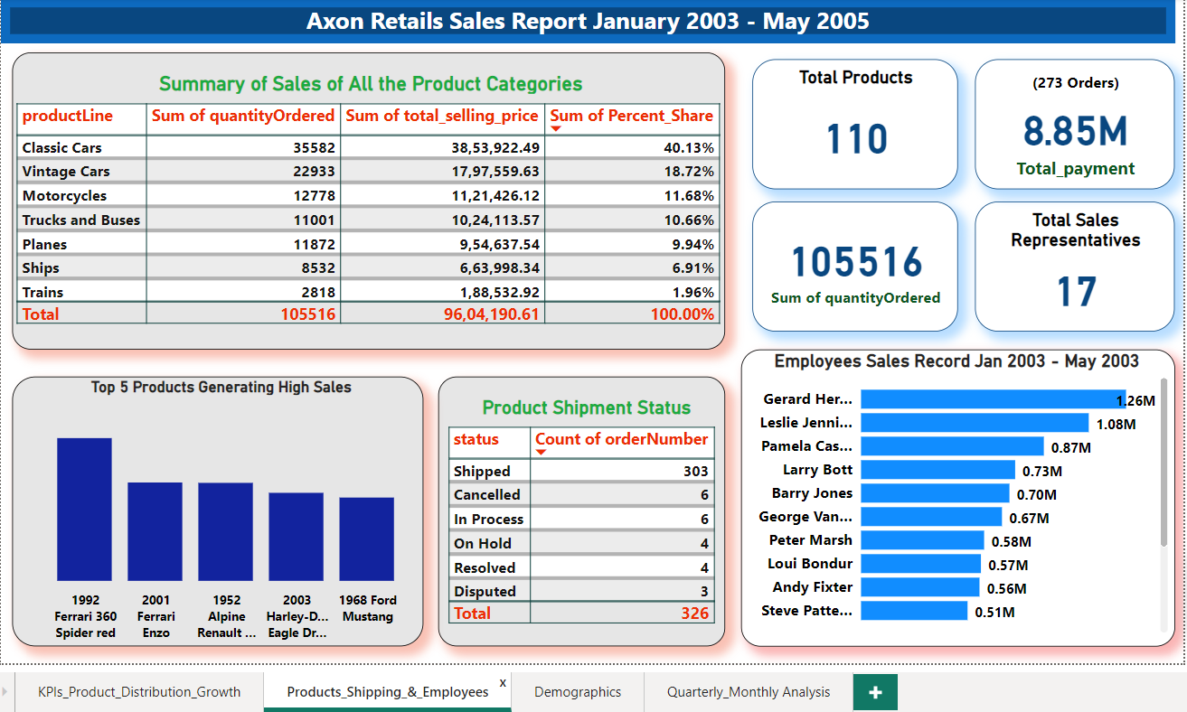

**Table Chart No 1- The first table chart shows the overview of sales data indicating all the product categories, their respective quantities ordered, total sales value of individual product category, their individual share in total sales value percentage and total sum of all the data**

**Column Chart- The column chart used here represents the top 5 products which generate high sales, these are crucial products for the company as they are either the most popular products ordered in high quantities or having high sales value because of their high price or they might be both high value as well as most ordered**

**Table Chart No 2- It shows the shipment status of the orders, to give the idea that how many of the orders are executed successfully and which orders require follow-ups**

**The Bar Chart- It shows the performance of sales representatives on the basis of sales value they have generated, It will help to assess the performance of the staff by evaluating their goal achievement, providing them regular feedbacks, giving recognitions and rewards**

**Customer Demographics and Geographical Analysis**

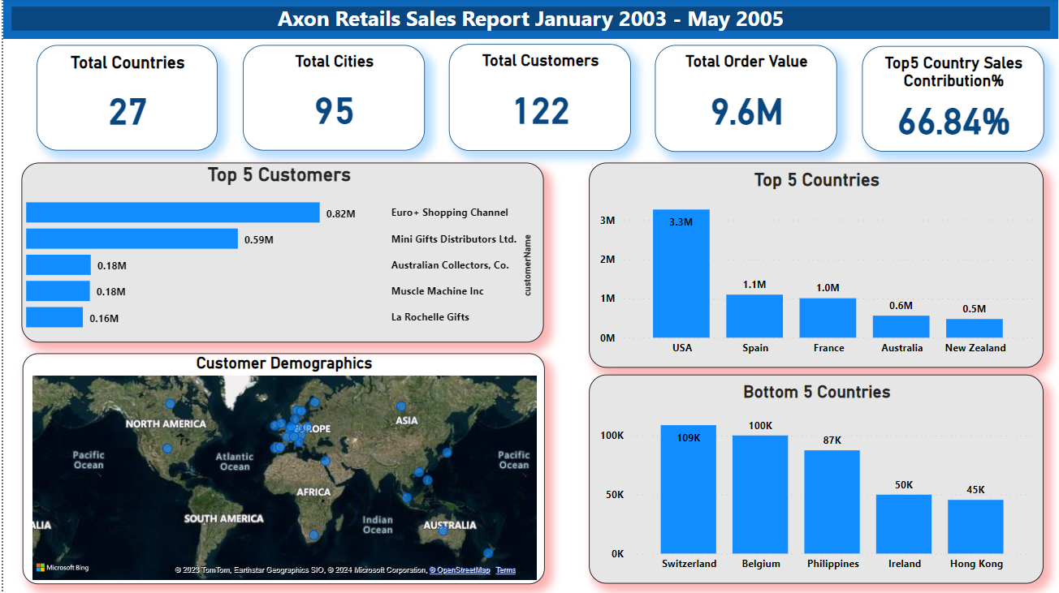

**Bar Chart- It shows the top 5 customers of the company who contribute a major portion of company’s revenue, The chart helps us to identify the most valuable customers for the company**

**Column Charts- Both the charts show top 5 countries and bottom 5 countries in terms of sales value, these charts will help us to frame strategy to increase sales in various countries by changing approach**

**Map Chart- It gives the overview of customer demographics, It shows the presence of company’s services in various countries across the globe**

**Analysing Monthly/Quarterly Variations, Sales Assessment Over a Period of Time**

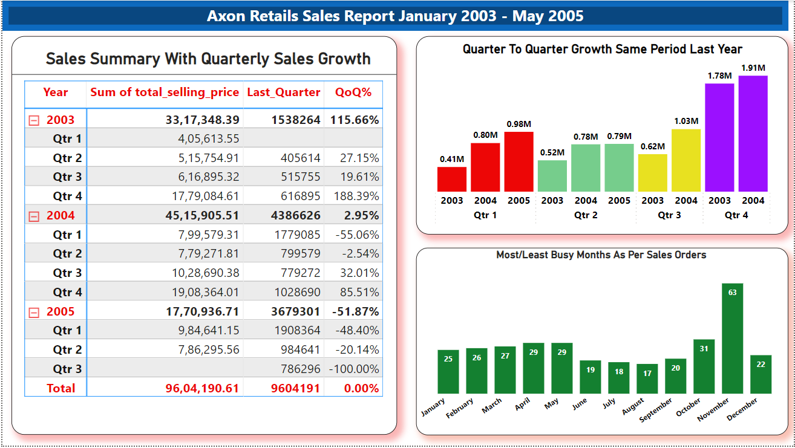

**Table Chart- The table chart is the summary of sales growth in terms of quarters, it shows quarterly progress of the sale starting from the first quarter of 2003 and ending at second quarter of 2005. It also shows the total sum of sales by the end of 2nd quarter of 2005**

**Column Chart No. 1- The first column chart shows the quarterly comparison across these years, to assess the performance from same period last year**

**Column Chart No. 2- It shows the monthly distribution of orders received by the company to identify the most busy months, however the data is not complete for the year 2005, but still this chart can give a rough idea from the available data that November can be considered a busy month**

**Conclusion**

**The analysis of key performance indicators for the company has provided valuable insights into various aspects of its operations. By defining clear objectives, selecting relevant KPIs, and employing effective data analysis techniques, we have gained a comprehensive understanding of company’s strengths, weakness and areas of improvement.**

**The examination of sales data, employee performance and other critical metrics has highlighted specific challenges and opportunities. The analysis of underperforming models, analysis of customer segmentation and monthly and quarterly assessment as well as retrospective study provides a foundation for targeted training and development initiatives.**

**By addressing these aspects, the company can enhance the effectiveness of its sales force, improve customer satisfaction and ultimately drive overall sales performance.**

-------------------------------------------------------------------------------------

**We have performed the SQL queries for similar sales insights from the data provided by the Axon Retailer**

**About the Dataset**

**The Data set contains 8 different tables. These tables collectively provide a relational database structure for managing various aspects of the car sale company’s operations, enabling efficient querying and reporting for better business insights.**

**Let’s query some key sales insights from the data**

**-- Profit percentage%**

**select**

**sum((ord.priceEach - pro.buyPrice) * ord.quantityOrdered)/sum(pro.buyPrice*ord.quantityOrdered) * 100 as total_profit_percent**

**from**

**orderdetails ord**

**join**

**products pro**

**on ord.productCode = pro.productCode;**

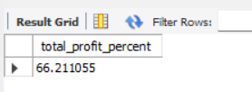

**-- Gross Profit Margin**

**select sum((ord.priceEach - pro.buyPrice) * ord.quantityOrdered)/sum(ord.priceEach*ord.quantityOrdered) * 100 as Gross_Profit_Margin**

**from**

**orderdetails ord**

**join**

**products pro on ord.productCode = pro.productCode;**

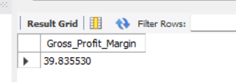

**1- Total count of the orders**

**select count(distinct orderNumber) as Total_Orders from orderdetails;**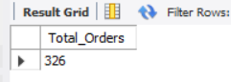

**2- Average value of the order-**

**select sum(quantityOrdered*priceEach)/ count(distinct orderNumber) as average_order_value from orderdetails;**

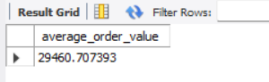

**3- Average quantity per order**

**select sum(quantityOrdered)/count(distinct orderNumber) as Avg_Qty_PerOrder from orderdetails;**

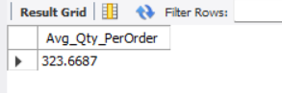

**4- Total Quantity of items ordered**

**select sum(quantityOrdered) as Sum_of_Quantity_Ordered from orderdetails;**

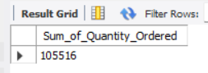

**5- Total number of customers**

**select count(distinct customerNumber) as Total_Customers from customers;**

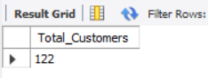

**6- Total number of countries where the company sells its products**

**select count(distinct country) as Total_Countries from customers;**

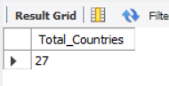

**7- Total number of cities across various countries where the company sells its products**

**select count(distinct city) as Total_Cities from customers;**

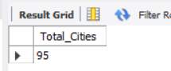

**8- Total value(selling price) of the orders received by the company**

**select sum(quantityOrdered*priceEach) as Total_Selling_Price from orderdetails;**

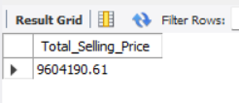

**9- Total payment made by the customer**

**select sum(amount) from payments;**

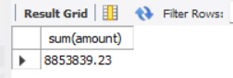

**Which is equal to 8.85 Million (up to two decimal places)**

**10- Order shipment status**

**select status, count(status) as Count_Of_Orders from orders group by status;**

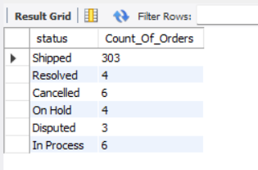

**11- Top 5 products based on quantity ordered**

**select productName, sum(quantityOrdered) as Quantity_Ordered from products inner join orderdetails on**

**products.productCode = orderdetails.productCode**

**group by productName**

**order by sum(quantityOrdered) desc limit 5;**

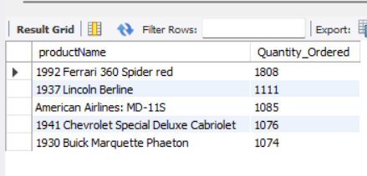

**12- Top 5 least ordered products based on quantity ordered**

**select productName, sum(quantityOrdered) as Quantity_Ordered from products inner join orderdetails on**

**products.productCode = orderdetails.productCode**

**group by productName**

**order by sum(quantityOrdered) asc limit 5;**

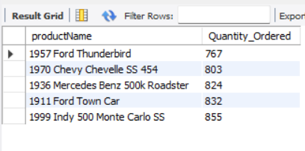

**13- Top 5 products generating high sales**

**select productName, sum(quantityOrdered * priceEach) as Sales_Value from products inner join orderdetails on**

**products.productCode = orderdetails.productCode**

**group by productName**

**order by sum(quantityOrdered * priceEach) desc limit 5;**

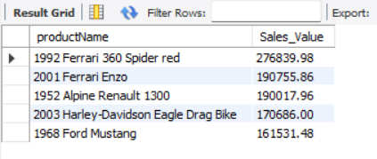

**14- Sales order quantity distribution, Sales value distribution and percentage share in total Sales value of each product category**

**select productline as Product_Category, sum(quantityOrdered) as Quantity_Ordered, sum(quantityOrdered*priceEach) as Sales_Value, (sum(quantityOrdered*priceEach)/(select sum(quantityOrdered*priceEach) from orderdetails)) * 100 as Percent_Share**

**from products inner join orderdetails**

**on products.productCode = orderdetails.productCode**

**group by productline**

**order by sum(quantityOrdered) desc;**

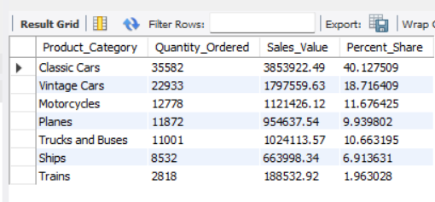

**15- Monthly distribution of sales orders to identify most and least busy months**

**select monthname(orderDate) as Month, count(distinct orderNumber) as Total_Orders**

**from orders**

**group by monthname(orderDate)**

**order by count(distinct orderNumber) desc;**

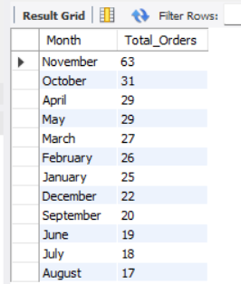

**16- Top 5 countries in terms of sales and their share% in total sale**

**select country, sum(quantityOrdered*priceEach) as Sale,**

**(sum(quantityOrdered*priceEach)/(select sum(quantityOrdered*priceEach) from orderdetails)) * 100 as Percent_Share_In_Total_Sale**

**from customers inner join orders**

**on customers.customerNumber = orders.customerNumbers**

**inner join orderdetails**

**on orders.orderNumber = orderdetails.orderNumber**

**group by country**

**order by Sale desc limit 5;**

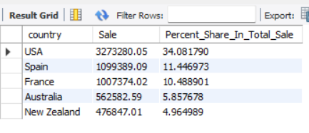

**17- Last 5 countries in terms of sales**

**select country, sum(quantityOrdered*priceEach) as Sale**

**from customers inner join orders**

**on customers.customerNumber = orders.customerNumber**

**inner join orderdetails**

**on orders.orderNumber = orderdetails.orderNumber**

**group by country**

**order by Sale asc limit 5;**

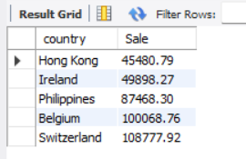

**18- Top 5 customers of the company placing high value orders**

**select customerName, sum(quantityOrdered*priceEach) as Sale**

**from customers inner join orders**

**on customers.customerNumber = orders.customerNumber**

**inner join orderdetails**

**on orders.orderNumber = orderdetails.orderNumber**

**group by customerName**

**order by Sale desc limit 5;**

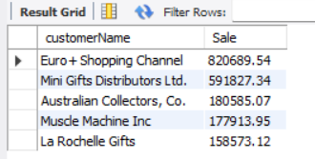

**19- Sales representatives' performance ranking based on the selling they have done**

**select concat(firstName,' ',lastName) as Employee_Name, sum(quantityOrdered*priceEach) as Sale**

**from employees inner join customers**

**on employees.employeeNumber = customers.salesRepEmployeeNumber**

**inner join orders**

**on customers.customerNumber = orders.customerNumber**

**inner join orderdetails**

**on orders.orderNumber = orderdetails.orderNumber**

**group by Employee_Name**

**order by Sale desc;**

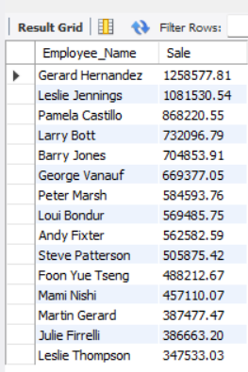

**20- Total number of products the company offers**

**select count(distinct productName) as Total_Products from products;**

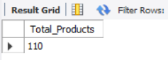

**21- Total sales representatives in the company**

**select count(distinct employeeNumber) as Total_Sales_Representatives from employees where jobTitle = 'Sales Rep';**

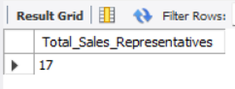

**-------------------------Thank You-------------------------**